Georgia Virtual School Credit Recovery Guidelines
Parkview High School 2017-2018 Fall Session
Program Requirements:
- Students must have previously failed the class with a 60 or above.
- GA Virtual School Credit Recovery classes are offered at no charge to students at GA Public Schools with a site coordinator.
- All post tests and final exams must be proctored by one of the site coordinators.
- The grade will be posted on the official transcript as a second course grade.
- If the course is an EOC course, the student must take the EOC at PHS with the testing staff.
Current credit recovery students will be moved to a CR advisement until completion of their CR course.
- Students will take all posttests during their Advisement/Lunch Period in Lab D (in the cafeteria).

Program Details:
- The student will create a Georgia Virtual Learning Student Account online.
- The student will return the enrollment agreement, located on the last page of this packet, signed by the student and parent, acknowledging all rules.
- Once the student is enrolled in the course by the site coordinator, the student can immediately begin the coursework. They must login within 10 days of enrollment.
- Students take a pretest at the beginning of each unit. If the score is 85% or higher, the student is allowed to proceed to the post test. If the pretest is less than 85%, the student must view the content in the unit. When all items are completed, the posttest will be available. A 70% or higher must be made in order to move to the next unit. Each course contains several units. Upon completion of all units, the final exam/EOC is given.
- Students have 24/7 access to complete assignments and move through each unit.
- Support is provided for the student by a Site Coordinator in Lab D (in the cafeteria) during Advisement.
- Upon enrollment, the student will be given a time frame to complete the course. If it is not completed within 26 weeks, the course will be dropped by GA Virtual School and all previous work will be lost.
- If a course expires prior to a student completing the course, the student will have to re-enroll and the course will start over from the beginning and NOT from where the student was at the time of expiration.
- Re-enrollment of the same course will have a required $25 administration fee.

*PLEASE NOTE: CREDIT RECOVERY IS NOT NCAA APPROVED. By signing up for Credit Recovery, the guardians and students will understand that the class will not meet NCAA Athletic Requirements.

SEE BACK OF THIS PAPER FOR A COMPLETE LIST OF COURSES OFFERED THROUGH GA VIRTUAL CREDIT RECOVERY

For detailed information about each course go to www.gacreditrecovery.org
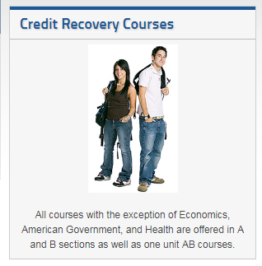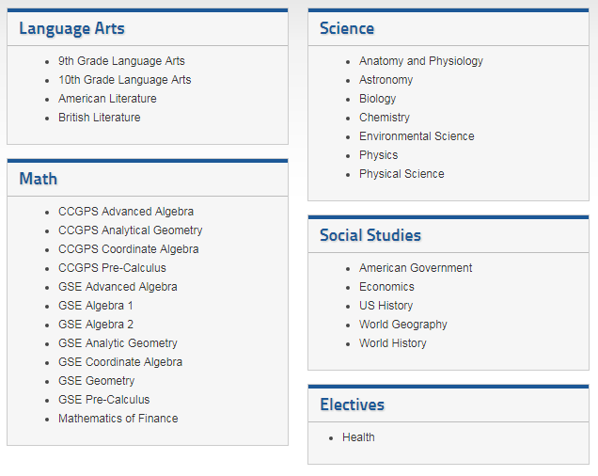

Georgia Virtual Credit Recovery Program
www.gacreditrecovery.org
Steps to success in credit recovery:
- Go to the Georgia Virtual School Credit Recovery Website and create an account.
- Turn in enrollment form to Site Coordinator in Lab D (in the cafeteria)
- Complete all course work by the completion date.
To Create a Georgia Credit Recovery Account:
1. Go to: www.gacreditrecovery.org
2. Click “Log In to Credit Recovery”
3. Click “Student Login”
4. In the top right corner click “Create Account” and create a “Student Account”
5. Immediately login to account to verify account creation.
6. Notify a Credit Recovery coordinator when you create your account.
The purpose of the Georgia Credit Recovery Program is to provide GA public high school students with an opportunity to recover credit for selected courses previously attempted and failed. It is a free online course and participants should have access to the internet away from school.

Now that you have created an account and have been enrolled in class, follow these steps to begin your class:
- Log in to www.gacreditrecovery.org. You must log into your course within 10 days of being enrolled in a course. You will gain access to your course within 24 hours of your initial log in to the system.
- Click on “My Classes” in the center of the screen.
- Your course will be in the upper right corner of the screen.
- Click on your course.
- Click on the “content” link.
- You can now see your table of contents for the course.
- Review the course welcome and course overview.
- You are now ready to take the pretest for unit one.
- Click on the pretest link.
If you score less than 85% on the pretest, you MUST complete the entire unit BEFORE the posttest link will be available.
Credit Recovery Post Test Procedures
STOP before you take the posttest. ALL posttests MUST be proctored by your Credit Recovery monitor.
** Posttests taken without proctored by the Credit Recovery monitor will be reset and require to be retaken.
A Credit Recovery monitor can be found in Lab D (in the cafeteria) Monday-Friday. If you need more assistance, contact Site Coordinator.
You must pass each unit posttest with a 70% or better.
The post test is currently set up to allow you three attempts at the post test. After three attempts, you will be temporarily stopped from attempting the test again. If this happens, follow the procedure below:
- Contact your credit recovery monitor and ask him to reset your posttest.
- Once the unit posttest has been reset, you will have three additional attempts to score 70% or better.
When the course is completed, your final grade will be added to your transcript. You can then begin another course if needed.

Credit Recovery Testing Procedures

ALL POSTTESTS MUST BE TAKEN UNDER SUPERVISION OF CREDIT RECOVERY COORDINATOR.

THE FINAL EXAM CAN ONLY BE ATTEMPTED ONE TIME.

Student/Parent Contract
The Georgia Credit Recovery Program
Georgia Virtual School (GVS)
Parkview High School
Date __________________
____________________________ (student name) has requested a course to be taken via The Georgia Credit Recovery Program.
The requested course is Semester ___ of ___________________________________ (course title)
with previous failing grade of _______. COHORT: 2017 2018 2019 2020
Student Information
Student Number __________________
Student GVS Account Username ____________________________________
Student Email ________________________________________
Guardian Name ______________________________________
Guardian Contact Number ______________________________
Guardian Email _______________________________________
I have read the stipulations stated on the back of this page, and I understand and agree to all terms. I also understand that I will be moved to a CR advisement to work on my CR course until completion.
____________________________________ ________________________________________________
Guardian Signature Date Student Signature Date

****FOR OFFICE USE ONLY****
Site Coordinator Signature __________________________________________ Date __________
Student GVS ID__________________ Enrollment ID___________________
Entered into CR Spreadsheet _______________________________________________________

*No student will be enrolled until the following terms have been agreed upon by parent, student, and the Credit Recovery monitor.
1. Students may only take courses that have been previously failed with a grade from 60-69% and may take only one CR course at a time.
2. Students must have an accessible email address in order to create a Credit Recovery account. A home computer with internet access is desirable. Parkview High School is not responsible for furnishing equipment needed for working outside of the school day. Students may need to work on CR courses at home in order to complete them on time.
3. Students are expected to make satisfactory weekly progress. Failure to make adequate progress may result in the student being withdrawn from the course or the course to expire before the course has been completed.
4. Enrollment in The Georgia Credit Recovery Program does not guarantee a passing score and the earning of credits. The student must earn a final average in the course of 70% or above with course work and unit tests counting 80% of the average and the final exam or EOC counting 20% of the final average.
5. All unit post tests and final exams must be taken in the presence of a school monitor. This is part of The Georgia Credit Recovery policy and is non-negotiable.
6. All coursework submitted must be your own, original work. Students must not cheat on any assignment by giving or receiving unauthorized assistance or committing the act of plagiarism. If such acts are committed, the student is subject to receiving a grade of zero on the assignment in question, as well as disciplinary action and/or removal from Credit Recovery.
7. If the student fails to meet all requirements, the student will be responsible for obtaining the credit through other means. If the student desires to re-enroll through The Georgia Credit Recovery Program to retake the same course, there will be a required $25 administration fee.
8. All Credit Recovery for seniors planning to participate in summer graduation must be completed by Tuesday June 25th, 2018.
*PLEASE NOTE: CREDIT RECOVERY IS NOT NCAA APPROVED. By enrolling and completing a Credit Recovery course, guardians and students understand that the course will not meet NCAA Athletic Requirements.

